Gripon, John Adrian G.

BSIT-301

**3. Provide the following items for each website or web application:**

a. Category and name of the website or Web application (3 points)

- Philippine airlines

- Barkota

b. Link to the website or Web application (2 points)

<https://www.philippineairlines.com/en/faq/online-booking>

<https://booking.barkota.com/search>

c. Properly labeled screenshots of the modules/pages you evaluated (5 points)

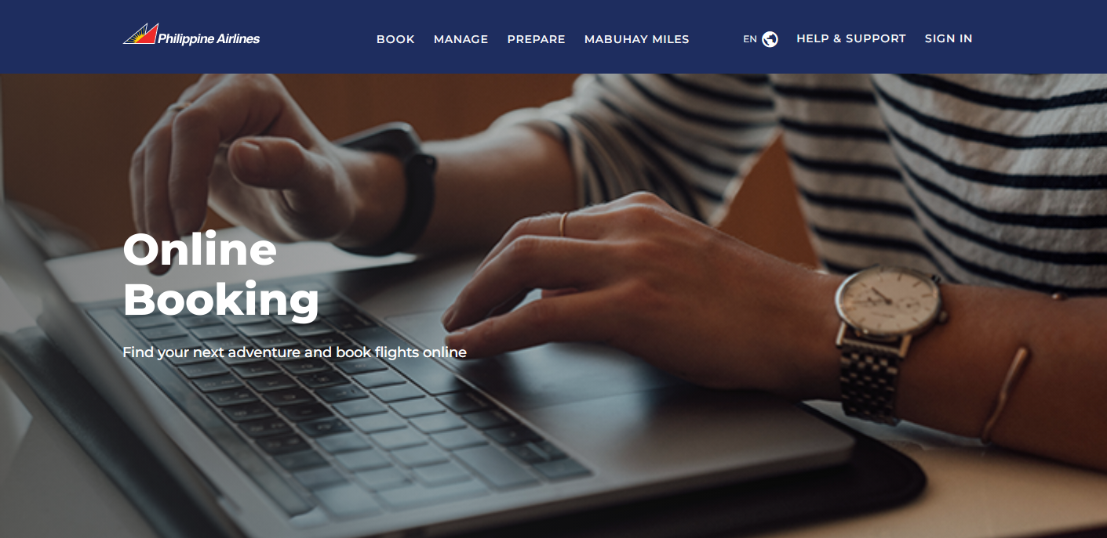

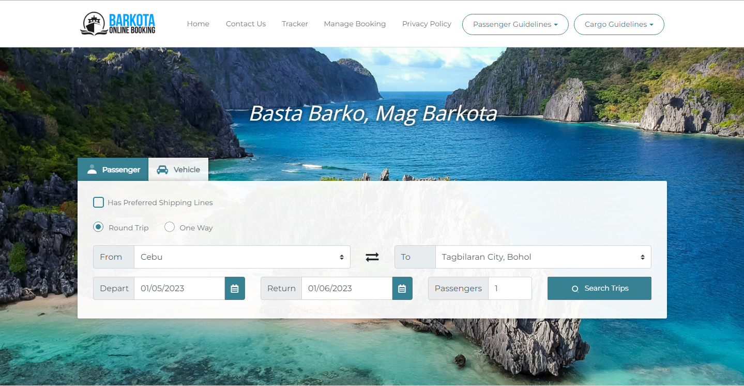

d. What method would you use to evaluate the website or Web application? Justify your answer in at least five (5) sentences. (Essay: 10 points)

When assessing any website, the following six (6) factors should be used: authority, accuracy, objectivity, currency, coverage, and appearance. There are various questions that should be asked for each criterion. More "yes" responses to questions indicate a higher likelihood that a website is of high quality.

4. Select one (1) website or Web application from Step 3 and create a simple evaluation survey. Use 08 Sample Evaluation Survey as a reference, but do not copy and paste the content.

|  |  |  |  |  |  |  |  |
| --- | --- | --- | --- | --- | --- | --- | --- |
| Website Capabilities | 0 | 1 | 2 | 3 | 4 | 5 | NA |
| The website was easy to navigate |  |  |  |  |  |  |  |
| The website had a professional look |  |  |  |  |  |  |  |
| Color choice was used consistently across every page |  |  |  |  |  |  |  |

5. Answer the evaluation survey that you created and briefly justify the ratings that you gave to the website or Web application. (Essay: 10 points)

|  |  |  |  |  |  |  |  |
| --- | --- | --- | --- | --- | --- | --- | --- |
| Website Capabilities | 0 | 1 | 2 | 3 | 4 | 5 | NA |
| The website was easy to navigate |  |  |  |  |  | **✓** |  |
| The website had a professional look |  |  |  |  |  | **✓** |  |
| Color choice was used consistently across every page |  |  |  |  |  | **✓** |  |

For me all of this is 5 because first It was easy to navigate. Second, it had a professional look because of the context and the graphics of the website was good and smooth if you use. Lastly the color of the website, for me the color of these website is attractive.